Enrollment System Modernization (ESM) Phase 2

Enrollment System (ES) 5.9

Release Notes



November 2019

Department of Veterans Affairs

Office of Information and Technology (OIT)

Table of Contents

1 Introduction 1

2 Purpose 2

3 Audience 2

4 This Release 2

4.1 Enhancements and Modifications 2

4.2 Defects and Fixes 13

4.3 Known Issues 14

5 Product Documentation 14

**List of Tables**

Table 1: ES 5.9 ESM Enhancements and Modifications 2

Table 2: ES 5.9 ESCC Enhancements and Modifications 9

Table 3: ES 5.9 SHRPE Enhancements and Modifications 10

Table 4: ES 5.9 ODM Enhancements and Modifications 12

Table 5: Defects and Fixes in ES 5.9 13

Table 6: Open Defects in the ES 5.9 Release 14

**List of Figures**

Figure 1: Document Management Tab 4

Figure 2: View Documents Panel 4

Figure 3: Document Management Panel 4

Figure 4: Search Documents Screen 5

Figure 5: Add New Comment Screen 5

Figure 6: Upload Documents Panel 6

Figure 7: Remove Document Screen 6

Figure 8: Document Management History Screen 7

Figure 9: Add Associate 7

Figure 10: Edit Associate 8

Figure 11: Delete Associate 8

# Introduction

The mission of the Department of Veterans Affairs (VA) Office of Information and Technology (OIT), Enterprise Program Management Office (EPMO) is to provide benefits to Veterans and their families. To meet this overarching goal, OIT is charged with providing high quality, effective, and efficient IT services and Operations and Maintenance (O&M) to persons and organizations that provide point-of-care services to our Veterans.

The VA’s goals for its Veterans and families include:

* Make it easier for Veterans and their families to receive the right benefits, and meet their expectations for quality, timeliness, and responsiveness.
* Improve the quality and accessibility of health care, benefits, and memorial services while optimizing value.
* Provide world-class health care delivery by partnering with each Veteran to create a personalized, proactive strategy to optimize health and well-being, while providing state-of-the-art disease management.
* Ensure awareness and understanding of the personalized, proactive, and patient-driven health care model through education and monitoring.
* Provide convenient access to information regarding VA health benefits, medical records, health information, expert advice, and ongoing support needed to make informed health decisions and successfully implement the Veteran’s personal health plans.
* Receive timely, high quality, personalized, safe, effective, and equitable health care, not dependent upon geography, gender, age, culture, race, or sexual orientation.
* Strengthen collaborations with communities and organizations, such as the Department of Defense (DoD), Department of Health and Human Services (DHHS), academic affiliates, and other service organizations.

To assist in meeting these goals, the Enterprise Health Benefits Determination (EHBD) program provides enterprise-wide enhancements and sustainment for the following systems/applications:

* The Enrollment System (ES) is the authoritative system for VA enrollment determination.
* Income Verification Match (IVM)/Enrollment Database (EDB) assists in determining priority grouping for healthcare eligibility.
* Veterans Information Systems and Technology Architecture (VistA) Registration, Eligibility & Enrollment (REE) shares information with other VistA applications and enables registration and preliminary eligibility determinations and enrollment at VA Medical Centers (VAMC). ES makes the final eligibility determinations.
* The Veteran’s On-Line Application (VOA), now referred to as Healthcare Application (HCA), enables Veterans to self-enroll in VA healthcare and is another entry point for records to be added to ES.

Enrollment System Modernization (ESM) defines Veteran Medical Benefit Plans (VMBP) for which a client (Veteran, service member, or beneficiary) is eligible and ties them to the authority for care. Key enhancements to be completed include pending eligibility determination, fixes to the Enrollment System, date of death, internal controls, workflow, Veterans Financial Assessment, converting of Military Service Data Sharing (MSDS) to Enterprise Military Information Service (eMIS), Manage Relationships, Veteran Contact Service, and support for Enrollment System Community Care (ESCC).

# Purpose

The purpose of this Release Notes document is to announce the release of the ES 5.9. This release, developed in Java technology, contains Enrollment System Modernization (ESM) Phase 2 development and upgrade efforts, including enhancements and defect fixes to support Enrollment System Community Care (ESCC), Suicide High Risk Patient Enhancements (SHRPE), and ES Sustainment.

# Audience

This document targets users and administrators of ES 5.9 and applies to the changes made between this release and any previous release for this software.

# This Release

ES will be upgraded from Version 5.8.0.16001 to Version 5.9 and hosted at the Austin Information Technology Center (AITC).

The following sections provide a summary of the enhancements and updates to the existing software and any known issues for ES 5.9.

## Enhancements and Modifications

**Enrollment System Modernization (ESM)**

Table 1 shows the ESM enhancements and modifications included in the ES 5.9 release as tracked in Rational Team Concert (RTC) Requirements Management (RM).

Table 1: ES 5.9 ESM Enhancements and Modifications

| **RTC RM #** | **Summary** |
| --- | --- |
| 773025 | Manage Documents in the Enrollment System |
| 888420 | Edit Existing Next of Kin Information |
| 888421 | Capture Emergency Contact Information Audit History |
| 888422 | View Emergency Contact Information |
| 888426 | Primary, Secondary Emergency Contact Information |
| 888427 | Add New Next of Kin Information |
| 888429 | View Next of Kin Information |
| 888432 | Add New Emergency Contact Information |
| 888438 | Delete Emergency Contact Information |
| 888442 | Save Edited Emergency Contact Information |
| 888443 | Transmit Emergency Contact Information to  VistA REE |
| 888444 | Edit Existing Emergency Contact Information |
| 888448 | Delete Next of Kin Information |
| 888452 | Capture Next of Kin Information Audit History |
| 888456 | Transmit Next of Kin Information to  VistA REE |
| 888463 | Save Edited Next of Kin Information |
| 888464 | Primary, Secondary Next of Kin Information |
| 914301 | Change Request (CR) 548398: Ability to Copy Permanent Address to Other Address Fields |
| 1076769 | CR 933624: Add New Designee Information |
| 1076771 | CR 933624: Edit Existing Designee Information |
| 1076772 | CR 933624: Save Edited Designee Information |
| 1076773 | CR 933624: View Designee Information |
| 1076774 | CR 933624: Capture Designee Information Audit History |
| 1089472 | Enable the Administrative Data Repository (ADR) Adapter to check address matching in ES before applying a BAI from VA Profile |
| 1113664 | Map Bad Address Reasons options in ES to Y when sending to VA Profile |
| 1147271 | Veteran Medical Benefit Plan (VMBP): Urgent Care Gap |
| 1155787 | Add Guardian Civil, Guardian VA, Power of Attorney options to Add a Person (AAP) - Add Associate Screen |

ES includes a new functionality that enables users to view and upload a Veteran’s documents in the Enrollment System.

* The system provides the Document Management capability setting for a user or role. This setting defines the user’s access to the Upload Documents panel on the Document Management screen. There are three capabilities:
  1. View – ES User (Add to the existing Observer Role)
  2. View and Upload - ES User (Add to the existing Edit Capability Role or Add a Person Role)

ES users cannot edit or delete their own comment after it has been added.

ES users can add multiple comments to their own record, one comment at a time.

ES users can view and upload a document.

* 1. View, Upload, and Remove – ES Advanced User

ES Advanced Users can go into their own or others’ records, back in time, to add a comment.

ES Advanced Users can add multiple comments to an existing record.

ES Advanced Users can view, upload and remove documents.

* A new “Document Management” tab is added to the ES Main Menu. All ES users have access to this tab.

Document Management Tab

Figure 1: Document Management Tab

* A new “View Documents” panel is added to the Overview page. The system displays the message “No Data on File” if no documents have been added to the Veteran’s View Documents panel.

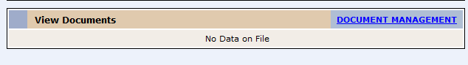

Figure 2: View Documents Panel

* The system displays the Document Management panel on the Overview screen.

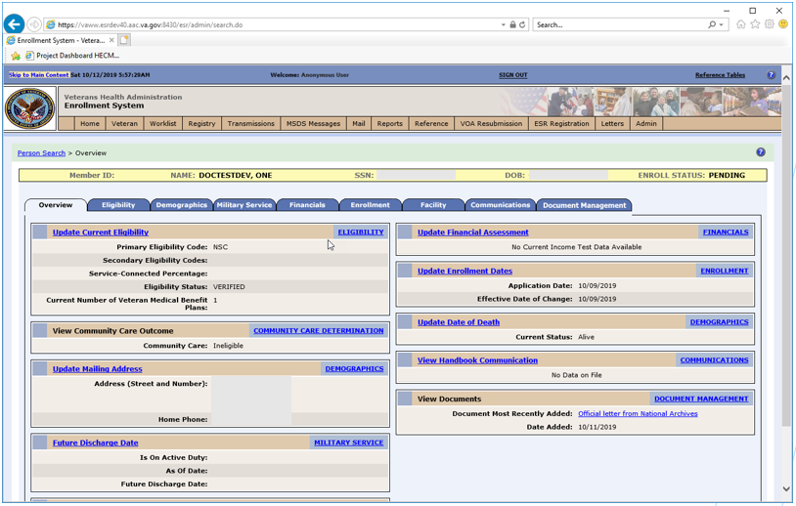

Figure 3: Document Management Panel

* Upon selection of the “Document Management” hyperlink or clicking Document Management, the system will display the “Search Documents” screen for all ES Users as the default view. The “View Documents” panel within the Search Documents screen contains a table with information about the documents.

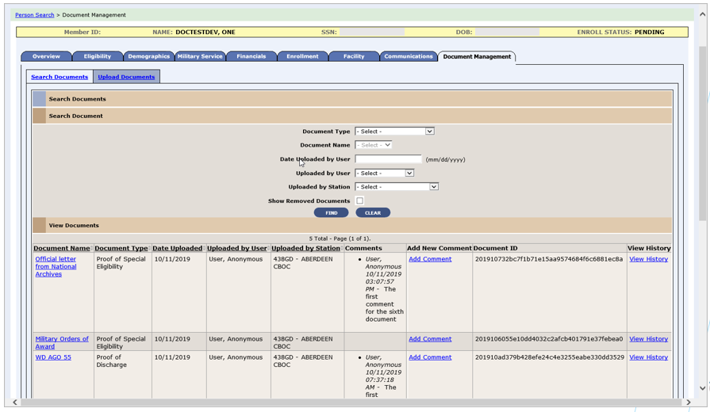

Figure 4: Search Documents Screen

* The record that was chosen on the “Search Documents” screen will populate the “Add New Comment” screen (for authorized ES users).

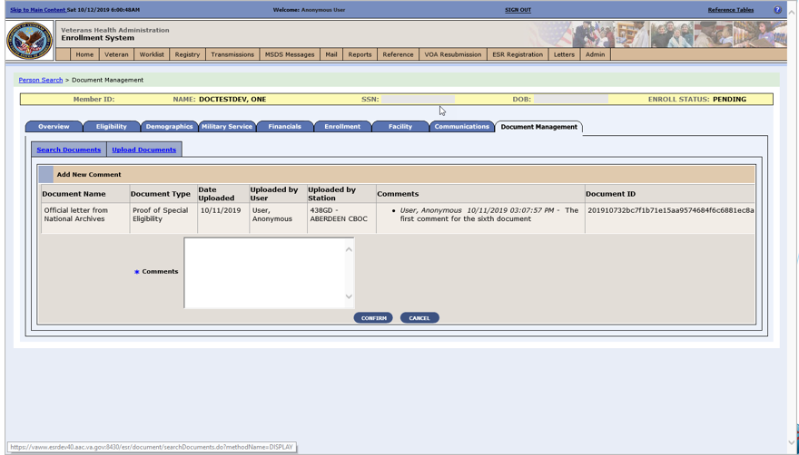

Figure 5: Add New Comment Screen

* The system displays the Upload Documents panel for authorized users. The ”View Documents” panel within the Upload Documents screen contains a table with information about the documents.

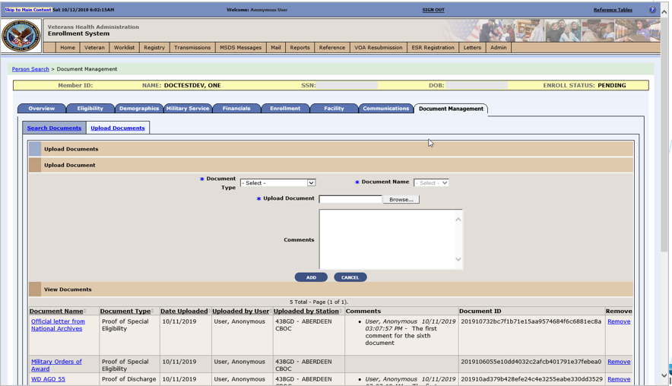

Figure 6: Upload Documents Panel

* When an authorized user selects the “Remove” button for one document at a time, the system navigates them to the Remove Document Screen. The Remove Document Screen populates and a Comment is required.

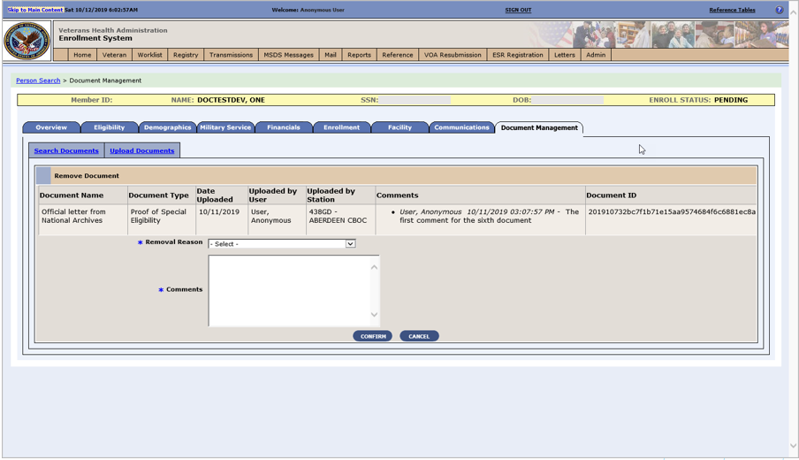

Figure 7: Remove Document Screen

* The Document Management History Screen includes viewing the history for a specific document and export features.

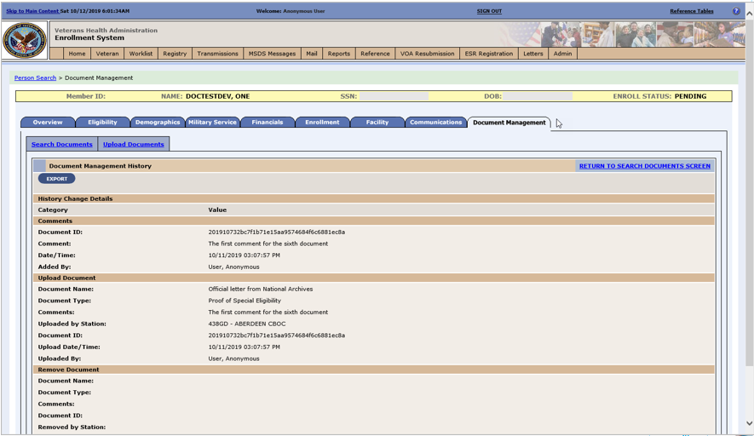

Figure 8: Document Management History Screen

ES is enhanced to allow entry, editing, and deletion of all associate types within Add a Person (AAP) and the Associates tab within the Demographics tab. ES is also enhanced to send all associate updates to VistA sites.

* A “Copy Existing Associate” dropdown field is added for all associate types in the Demographics -> Associates -> Add Associate and the Demographics -> Associates -> Update Associate pages and a “Copy Permanent Mailing Address from Veteran” checkbox is added.

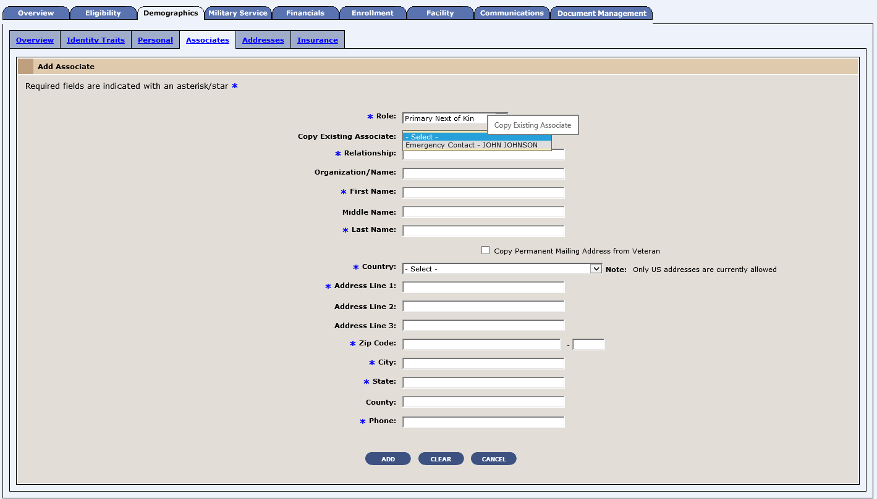

Figure 9: Add Associate

* Only a single Designee, Emergency Contact, Other Emergency Contact, Primary Next of Kin, or Other Next of Kin is allowed. If a user selects the “Role” of an existing associate in that list, a popup is displayed asking if the user would like to delete the existing associate. Along with the existing editable associates (Guardian Civil, Guardian VA, Power of Attorney), Designee, Emergency Contact, Other Emergency Contact, Primary Next of Kin, and Other Next of Kin associate types display as hyperlinks within the Name column on the Demographics -> Associates page when outside of the Add a Person module.

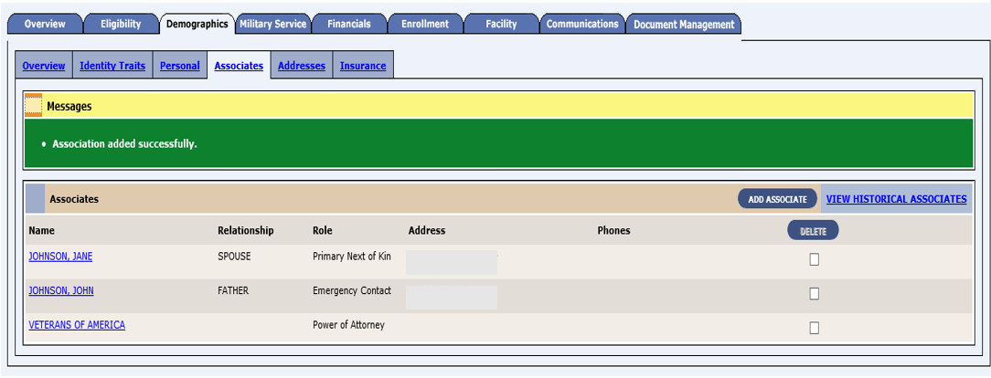

Figure 10: Edit Associate

* A “Delete” button is added to the Demographics -> Associates page.

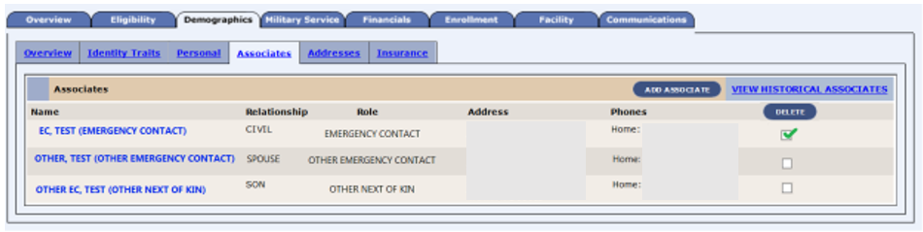

Figure 11: Delete Associate

The ADR Adaptor has been enabled to check address matching in ES before applying a bad address indicator (BAI) from VA Profile. There are no user interface changes associated with this enhancement.

ES has added two new core Veteran Medical Benefit Plans and the necessary rules to support their assignment to specific groups of Veterans:

* Veteran - Full Medical Benefits Treatment & Rx Copay Exempt (X) (Short Description: FM 6)
* Veteran - Full Medical Benefits Treatment Copay Exempt & Rx Copay Required (Y) (Short Description: FM RxCo 6)

**Enrollment System Community Care Enhancements (ESCC)**

Table 2 shows the ESCC enhancements and modifications included in the ES 5.9 release as tracked in RTC RM.

Table 2: ES 5.9 ESCC Enhancements and Modifications

| **RTC RM #** | **Summary** |
| --- | --- |
| 1051868 | ESCC Quality  * Will not include data for Planning System Support Group (PSSG) Geocoding or for Veteran Medical Benefit Plan |
| 1153510 | ES 5.9.0 Maintain the Enrollment System (Feature 1147917: 986813 Defect Fix for Veteran Health Benefit Plan History – Display “Last Updated” time and “Last Updated By” fields of deleted Medical Benefit Plans on the Medical Benefit Plans History screen |
| 1153551 | Determining Community Care eligibility using surviving and deprecated records for the same person |
| 1156756 | Manual override/grant Urgent Care eligibility |

ES has discontinued filtering out deprecated records for the same person when matching records for the qualifications for the Community Care Program, so if either one of the duplicate records have qualifying criteria in which the Veteran is considered enrolled, then that data can be applied to the surviving record for determining Community Care eligibility. Community Care eligibility will be calculated based on eligibility factors found on the surviving and deprecated record(s) for that Veteran and the eligibility outcome(s) and/or Veteran Medical Benefit Plan(s) are made/stored/displayed/shared in ES, VistA, Computerized Patient Record System (CPRS), Eligibility and Enrollment (E&E) web service, and in files to the contractors (i.e., Third-Party Administrator (TPA) and CCN).

A daily report, specifically for Community Care, is generated out of ES to optimize and expose any potential trouble areas in the extract, transform, load (ETL) jobs and specific ES interfaces.  This report is created out of Oracle and displayed as part of a daily email sent to an authorized ES User Mail Group. The report is generated in the morning to include data from the day before.

Authorized ES users can manually grant Community Care Urgent Care static eligibility for an enrolled Veteran when approval is received from the Office of Community Care so that Veterans’ records can reflect the accurate eligibility for 2 years. The updated Urgent Care eligibility displays on the Overview page, Community Care Determination Screen, and on the Community Care Determination History Screen and triggers downstream processes to include determining the VMBP and communicating Community Care eligibility within VA and with external partners.

**Suicide High Risk Patient Enhancements (SHRPE)**

Table 3 shows the SHRPE enhancements and modifications included in the ES 5.9 release as tracked in RTC RM.

Table 3: ES 5.9 SHRPE Enhancements and Modifications

| **RTC RM #** | **Summary** |
| --- | --- |
| 1088851 | Implement EXPANDED MH CARE NON-VETERANS as Primary Eligibility Code |
| 1088852 | Implement EMERGENT MH OTH as Eligibility Factor |
| 1088853 | EMERGENT MH OTH mapped to EXPANDED MH CARE NON-VETERANS |
| 1088854 | EMERGENT MH OTH mapped to NOT APPLICABLE |
| 1088855 | Eligibility Code Changes Reflected in VistA |
| 1088856 | Track OTH Eligibility Periods of Care |
| 1089003 | Implement Extended MH OTH as Eligibility Factor |
| 1089004 | Extended OTH Mapped to EXPANDED MH CARE NON-VETERANS |
| 1089005 | Extended OTH Mapped to NOT APPLICABLE |
| 1161819 | New "Expanded Mental Health" Eligibility Functionality and OTH Periods |

The SHRPE enhancements will identify eligibility for emergency mental health care services for former service members with other than honorable (OTH) administrative discharge and track their care. The enhancements involve addition of a new "Expanded MH Care Non-Enrollee" non-Veteran primary eligibility code; addition of two new eligibility factors to identify the OTH-related mental health care reason; and addition of 90-day tracking cycles, where applicable, in ES. ES will send the new eligibility code, the OTH eligibility factor, and other related data to VistA sites using the existing framework (HL7 messaging).

* “Expanded MH Care Non-Enrollee” is added as a Non-Veteran Primary Eligibility Code on the Edit Current Eligibility screen. It can also be accessed through Add a Person. Radio buttons with Yes/No/No Data options are displayed. The default is “No Data”.

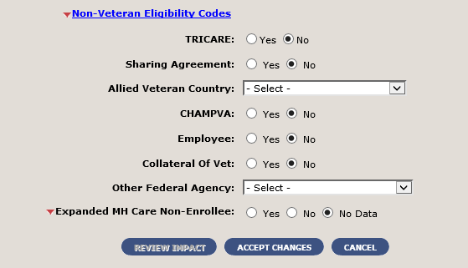

* If the user selects “Yes”, then this section is expanded to display the ‘OTH Eligibility Factor’ drop-down field with the values “Emergent MH OTH” and “Extended MH OTH”. The default value is “Select”. The user is required to select one value from the drop-down list.

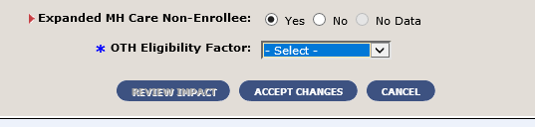

* When the value is selected, the Add 90-Day Period button appears.

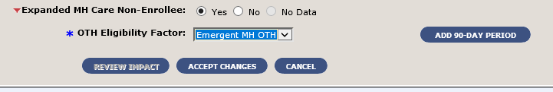

* After the user selects the button, a grid with the additional fields is displayed. For the initial 90-day period of care, the system sets all the applicable fields.

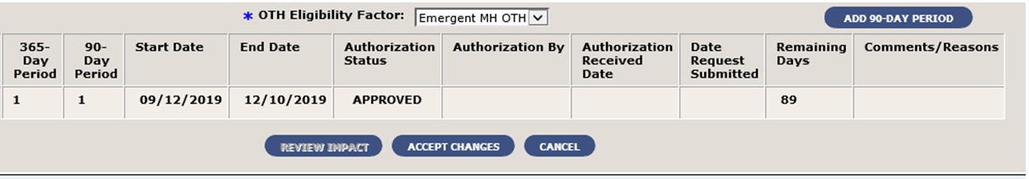

* When necessary, the user may add a subsequent 90-day period of care; the system verifies that an initial 90-day period exists within a current 365-day period. The system does not allow the user to add more than one subsequent 90-day period (“Pending” or “Approved” status) during the current 90-day period of care. The system displays an “Authorization Status” drop-down with the following options: Approved, Denied, or Pending.

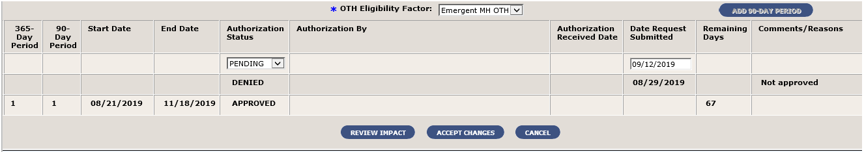

* An ES user with required permissions has the authority to edit or delete the 90-day periods of care information for the current 365-day period. An ES user with required permissions has the authority to edit a 90-day period of care (for the purpose of correcting data only). The system adjusts any other affected dates once another 90-day period has been edited.

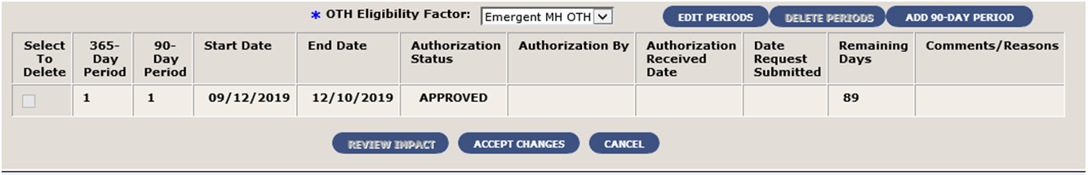

* The system displays the new Primary Eligibility Code on the Eligibility Screen. The system displays a new section called “Expanded Mental Health Care” on the Eligibility Screen. The new section is located after the “Other Ineligibility” section. The new section displays the following information: If not applicable, then “No Data Available” is displayed; If “Extended MH OTH”, then only the OTH Eligibility Factor is displayed; If “Emergent MH OTH”, then the OTH Eligibility Factor and the grid are displayed

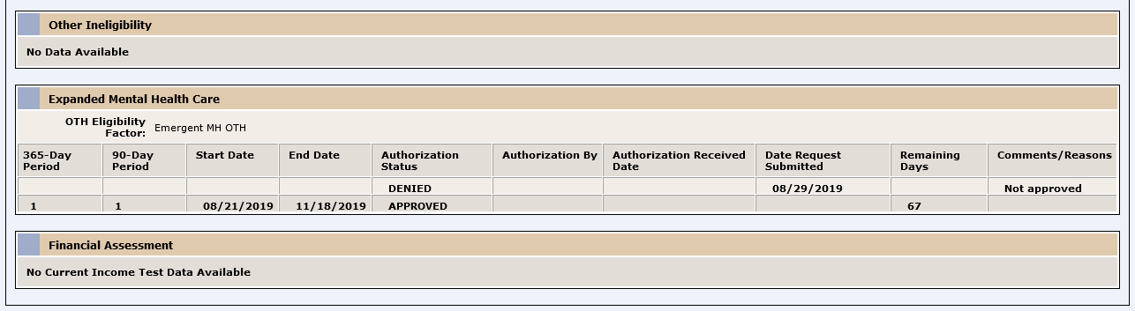

**Operational Decision Manager (ODM)**

Table 4 shows the ODM enhancements and modifications included in the ES 5.9 release as tracked in RTC RM.

Table 4: ES 5.9 ODM Enhancements and Modifications

| **RTC RM #** | **Summary** |
| --- | --- |
| 1076447 | Integrate Dependent Validation rules set. |
| 1076455 | Integrate Spouse Validation rules set. |
| 1090583 | Integrate Link Person Registry rules set. |
| 1090613 | Integrate Military Service Validation rules set. |

Under ODM, the 71 iLOG rule sets were transferred from iLOG to ODM. A Mediation Framework was established to allow the system administrators to switch between the iLOG and ODM rules sets as the rules sets are integrated into the ES application. Once the migration is fully completed to ODM, the rules will not be switched back to iLOG unless there is a systemic issue with ODM. ES 5.9 supports integration of the Dependent Validation, Spouse Validation, Link Person Registry, and Military Service Validation rule sets.

## Defects and Fixes

Table 5 lists the defects and fixes and corresponding Rational Team Concert (RTC) Change and Configuration Management (CM) numbers included in ES 5.9 (RM# 1153510: ES 5.9.0 Maintain the Enrollment System).

Table 5: Defects and Fixes in ES 5.9

| **RTC CM #** | **Summary** |
| --- | --- |
| 1015762 | **Defect:** Error reports are detected when trying to display the Community Care Determination screen.  **Fix:** The code was looking for old data, which, if found, would prevent display of the screen. References to the old data in the code have been removed. |
| 1069933 | **Defect:** A residential address change was not triggering the necessary VCE recalculation.  **Fix**: A back-end change in Production was made to resolve the issue. |
| 1108368 | **Defect:** If the Veteran is not enrolled then Pending; Eligibility Unverified, Pending; Means Test Required (No Prior Enrollment), the Community Care outcome should be Ineligible.  **Fix**: A Veteran with no prior period of enrollment is assigned a VCE of Ineligible even if there is no existing VCE. |
| 1111363 | **Defect:** A null date of birth (DOB) and incorrect format for date of death (DOD) is being sent to CCN Contractor, Region 1.  **Fix**: Updated code to use date_of_birth_txt (string) and not date_of_birth (date); updated DOD format when date is imprecise. |
| 1114232 | **Defect:** CCN file contains deceased and not enrolled records.  **Fix**: If the Veteran is not enrolled or is now ineligible, the record is checked to determine whether the record was ever sent to CCN contractors. If it was, a status of ineligible will be sent. |
| 1119805 | **Defect:** Residential addresses with state code "CA" are not flagged for geocoding.  **Fix**: "CA" was being filtered out from geocodable states; updated code to include “CA” in states that can be geocoded. |
| 1119845 | **Defect:** Residential address changes made for not-enrolled status are excluded from geocoding as per design. However, when the Veteran's enrollment changes to enrolled, the address in geocoding transmit is out of sync with the residential address. For enrolled Veterans, if the geocoding transmit is out of sync with the residential address, the residential address should be flagged for geocoding.  **Fix**: The VCE recalculation is modified so that when an enrolled Veteran is being calculated, if the geocoding transmit address is not in sync with the residential address, the residential address is flagged for geocoding. If the address line 1, city, state, and zip code are not the same, the address is considered to be out of sync. |
| 1122348 | **Defect:** CCN seeding file contains deceased and not enrolled records. The initial file should exclude deprecated persons.  **Fix**: Updated database to exclude deprecated persons. |
| 1122672 | **Defect:** Veterans residing in Philippine Islands should qualify for N VCE. The residential address could have a country code of "PHL" or a state code of "PH" or "PI". All such addresses qualify for N VCE.  **Fix**: Updated code to allow PI state to be in N state when VCE parameter for N State is PH. This will make records with PI state code eligible for N VCE. |
| 1132140 | **Defect:** If state code is PH the ES to PSSG ETL will filter out and not send to PSSG for geocoding.  **Fix**: ES to PSSG and ES to PSSG monthly ETL code is modified to not exclude the PH state code from states that can be geocoded. |
| 1138817 | **Defect:** ES is not able to receive Other Health Insurance (OHI) data if there is no insurance company fax number.  **Fix**: Added a null and blank check for carrier phone and fax so that an individual record exception can be caught and logged and then other records can be processed. |

## Known Issues

Table 6 lists identified defects that remain open in this release.

Table 6: Open Defects in the ES 5.9 Release

| RTC CM # | Summary |
| --- | --- |
| 1154606 | ESCC Quality Report Urgent Care section shows incorrect count of records with “U”. |

# Product Documentation

The following documents apply to this release:

* ES 5.9 Release Notes are uploaded to the [VA Software Document Library](http://www.va.gov/vdl/) (VDL).
* Additional reference documentation related to this release is stored in RTC.